1. Threat Hunting Methodologies

Threat hunting is a proactive cybersecurity technique where security analysts actively search for hidden threats that may evade traditional detection systems such as firewalls, antivirus, or SIEM alerts. Unlike reactive security approaches, threat hunting assumes that attackers may already be present within the system and focuses on identifying indicators of compromise (IOCs) and attacker behaviors.
Threat hunting is highly dependent on understanding attacker tactics, techniques, and procedures (TTPs), often mapped using the MITRE ATT&CK framework. It helps detect stealthy attacks such as credential misuse, lateral movement, and privilege escalation.
A fundamental concept in threat hunting is the hypothesis-driven approach, where analysts form a logical assumption based on threat intelligence, anomalies, or observed patterns. This hypothesis is then tested using available data sources.

Core Concepts

- Proactive Threat Hunting
  - Focuses on actively identifying threats before alerts are triggered
  - Assumes breach mentality (attackers may already be inside the system)
  - Example: Detecting valid account misuse (T1078)
- Hypothesis-Driven Approach
  - Analysts create and test hypotheses based on intelligence or anomalies
  - Example: Suspicious increase in failed login attempts followed by success
- Types of Threat Hunting
  - Structured Hunting → Based on known indicators and TTPs
  - Unstructured Hunting → Based on anomalies or unusual patterns
  - Situational Hunting → Based on specific events or alerts
- Hunting Frameworks
  - SqRR (Search, Query, Retrieve, Respond)
    - A systematic approach to hunting activities
  - TaHiTI
    - Integrates threat intelligence with hunting processes
- Data Sources for Hunting
  - Endpoint logs (process creation, file access)
  - Network logs (DNS queries, traffic flow)
  - Authentication logs (login attempts)
  - Cloud logs and API activity
  - Threat intelligence platforms
- Common Hunting Techniques
  - Log analysis and correlation
  - Behavioral analysis
  - Anomaly detection
  - IOC matching

Key Objectives

- Identify hidden threats before escalation
- Detect advanced persistent threats (APTs)
- Improve visibility across endpoints and networks
- Strengthen proactive defense strategies

2. Advanced SOAR Automation

Security Orchestration, Automation, and Response (SOAR) platforms are designed to improve the efficiency and effectiveness of SOC operations by integrating multiple security tools and automating workflows. SOAR reduces manual workload by automating repetitive tasks and enabling faster response to incidents.
SOAR systems connect tools such as SIEM, EDR, threat intelligence platforms, and ticketing systems into a centralized platform. They use playbooks, which are predefined workflows, to automate incident handling processes.

Core Concepts
- Security Orchestration
  - Coordination and integration of multiple security tools
  - Enables seamless communication between systems
- Security Automation
  - Automates repetitive tasks such as alert triaging, enrichment, and response
  - Reduces human error and increases speed
- Incident Response
  - Automated or semi-automated actions taken to contain and remediate threats
  - Includes actions like blocking IPs, isolating hosts, or disabling accounts
- Playbooks
  - Step-by-step workflows designed for specific incident types
  - Can be fully automated or require human approval

Playbook Development

Example: Malware Incident Playbook
- Receive alert from SIEM
- Analyze file hash and behavior
- Check reputation using threat intelligence
- Isolate affected endpoint
- Remove malicious file
- Generate incident report

Integration with SIEM/EDR
- SIEM provides centralized logging and alert generation
- EDR provides endpoint-level monitoring and response
- Threat intelligence enriches alerts with external data

Benefits of SOAR
- Faster incident response
- Reduced analyst workload
- Standardized response procedures
- Improved accuracy and consistency

Key Objectives
- Reduce Mean Time to Respond (MTTR)
- Automate SOC workflows
- Improve operational efficiency
- Enhance incident handling capabilities

3. Post-Incident Analysis and Continuous Improvement

Post-incident analysis is a crucial phase in the cybersecurity lifecycle where organizations evaluate incidents after they have been resolved. The purpose is to understand how the attack occurred, identify weaknesses, and improve future defenses.
This phase ensures that organizations learn from incidents and continuously enhance their security posture.

Core Concepts

- Root Cause Analysis (RCA)
  - Identifies the underlying cause of an incident
  - Focuses on eliminating the root issue rather than symptoms
- 5 Whys Technique
  - A problem-solving method that involves asking “Why?” multiple times
  - Helps trace the root cause logically
- Fishbone Diagram
  - Visual tool used to identify contributing factors
  - Categories include:
    - People (human errors, lack of training)
    - Process (inefficient procedures)
    - Technology (system vulnerabilities)
- Lessons Learned
  - A structured review process after incident resolution
  - Identifies strengths and areas for improvement

SOC Metrics and KPIs
- MTTD (Mean Time to Detect) → Detection efficiency
- MTTR (Mean Time to Respond) → Response efficiency
- Dwell Time → Time attacker remains undetected
- False Positive Rate → Accuracy of alerts

Incident Documentation
- Timeline of events
- Attack vector and entry point
- Impact analysis
- Actions taken during response

Key Objectives
- Identify root causes
- Improve detection and response strategies
- Reduce recurrence of incidents
- Strengthen overall security posture

4. Adversary Emulation Techniques

Adversary emulation involves simulating real-world cyberattacks based on known attacker behaviors to evaluate the effectiveness of security defenses. It helps organizations understand how attackers operate and whether their detection mechanisms can identify such activities.
Adversary emulation is based on the MITRE ATT&CK framework, which categorizes attacker techniques across different stages of an attack lifecycle.

Core Concepts
- Adversary Emulation
  - Simulates real attacker activities in a controlled environment
  - Used for testing detection and response capabilities
- Tactics, Techniques, and Procedures (TTPs)
  - Tactics → Objective (e.g., Initial Access)
  - Techniques → Method (e.g., phishing)
  - Procedures → Specific implementation
- MITRE ATT&CK Framework
  - Provides a structured mapping of attacker behaviors
  - Covers stages such as:
    - Initial Access
    - Execution
    - Persistence
    - Privilege Escalation
    - Lateral Movement

Emulation Tools
- MITRE Caldera (automated emulation)
- Metasploit (penetration testing)
- Red Team tools for attack simulation
- Blue Team tools for detection

Red-Blue-Purple Teaming
- Red Team → Simulates attacker behavior
- Blue Team → Defends and detects
- Purple Team → Collaboration between both teams

Use Cases
- Testing SIEM detection rules
- Validating endpoint security controls
- Measuring SOC effectiveness

Key Objectives
- Identify detection gaps
- Improve monitoring capabilities
- Strengthen incident response
- Validate security controls

5. Security Metrics and Executive Reporting

Security metrics are used to evaluate the performance of SOC operations and measure the effectiveness of cybersecurity controls. Executive reporting translates technical findings into meaningful insights for management and decision-makers.
Metrics provide visibility into how well an organization detects, responds to, and prevents security incidents.

Core Concepts
- SOC Performance Metrics
  - MTTD (Mean Time to Detect)
  - MTTR (Mean Time to Respond)
  - Dwell Time
  - False Positive Rate
  - Incident Resolution Rate
- Operational Metrics
  - Number of incidents detected
  - Number of incidents resolved
  - Alert volume trends
  - Analyst workload
- Executive Reporting
  - Focuses on high-level insights
  - Uses dashboards, graphs, and summaries
  - Communicates business impact of security incidents

Reporting Components
- Incident trends over time
- Detection and response performance
- Risk assessment and impact analysis
- Recommendations for improvement

Continuous Improvement Using Metrics
- Metrics help identify inefficiencies
- Enable tuning of detection rules
- Support automation improvements
- Assist in resource allocation

Key Objectives
- Measure SOC effectiveness
- Provide actionable insights to management
- Improve decision-making
Phase 1: Advanced Post-Exploitation Analysis Report

1. Objective

The primary objective of this phase is to conduct an in-depth analysis of post-exploitation activities carried out on a compromised Windows 10 (22H2) system. This phase focuses on evaluating the attacker’s ability to escalate privileges from a standard user account to SYSTEM-level access, which represents the highest level of control within the Windows operating system.
In addition to privilege escalation, this phase also examines the attacker’s use of stealthy surveillance techniques, such as keylogging and screen capture, to gather sensitive information without being detected. The objective further includes identifying security controls that successfully prevented escalation, as well as highlighting potential detection opportunities for Security Operations Center (SOC) teams.
This analysis is essential for understanding attacker behavior during the post-exploitation phase and for improving defensive mechanisms against similar real-world threats.

2. Technical Attack Summary

Following the initial compromise, the attacker established a secondary Command-and-Control (C2) session to continue interaction with the compromised host. This new session (Meterpreter Session 2) was specifically created to attempt a User Account Control (UAC) bypass, which is a common technique used by attackers to gain elevated privileges without triggering user prompts.
The attacker utilized the bypassuac_silentcleanup module, which exploits weaknesses in Windows scheduled tasks and registry configurations to execute processes with elevated privileges. The goal of this step was to overcome previous limitations where actions were restricted due to insufficient permissions.
Despite successfully establishing the session, the attacker encountered restrictions imposed by modern Windows security enhancements. These protections are designed to prevent unauthorized privilege escalation and limit the impact of compromised accounts.

Metric | Details
Attacker IP | 192.168.0.110 (Kali Linux)
Victim IP | 192.168.0.111 (Windows 10)
Bypass Module | exploit/windows/local/bypassuac_silentcleanup
Session Established | Meterpreter Session 2 (2026-04-01 04:04:17)

3. Post-Exploitation Activity Analysis

A. Privilege Escalation Attempt (MITRE ATT&CK: T1068)
During this stage, the attacker attempted to elevate privileges using the getsystem command within the Meterpreter environment. This command leverages multiple techniques, including named pipe impersonation and token duplication, to gain SYSTEM-level access.
- Command Executed: getsystem
- Outcome: FAILED
Detailed Analysis:
Although the compromised account was part of the Administrators group, the process was executed under a non-elevated (medium integrity) context. Modern Windows 10 (22H2) systems enforce strict User Account Control (UAC) policies that prevent automatic elevation of privileges without explicit user consent.
Additionally, built-in exploit mitigation techniques, such as Protected Process Light (PPL) and Exploit Guard, may have prevented the successful execution of privilege escalation techniques. These controls block unauthorized attempts to manipulate system-level tokens or impersonate privileged processes.
Security Implication:
The failure of this attempt demonstrates the effectiveness of endpoint security controls in preventing attackers from gaining full system access, even after an initial compromise.
Detection Opportunity:
Such activity is typically logged as Audit Failure events in the Windows Security Event Log. Monitoring these logs can help SOC analysts detect early-stage privilege escalation attempts before they succeed.

B. Stealth Data Collection (MITRE ATT&CK: T1056.001 – Keylogging, T1113 – Screen Capture)
After failing to escalate privileges, the attacker adapted their strategy and shifted focus toward covert surveillance and data collection. This is a common tactic used by attackers to gather sensitive information, such as user credentials, without requiring elevated privileges.
Keylogging Activity
The attacker initiated a keylogging process to capture user keystrokes:
- Command: keyscan_start (successful execution)
- Data Retrieval: keyscan_dump
- Captured Data: "hello world<CR>"
Analysis:
Keylogging enables attackers to monitor user input in real time, including login credentials, emails, and other confidential data. This technique operates silently in the background, making it difficult for users to detect.

Screen Capture Activity
The attacker also performed screen capture to visually monitor user activity:
- Result: Successful screenshot capture
- File Location: /home/kali/UVQODiZH.jpeg
Analysis:
Screen capture provides attackers with contextual information that may not be available through keylogging alone. This includes open applications, sensitive documents, and user workflows.

Impact Assessment
The successful execution of these techniques highlights a critical security concern:
Even without SYSTEM-level privileges, attackers can still compromise user confidentiality and privacy.
Potential Risks Include:
- Credential theft
- Exposure of sensitive organizational data
- Monitoring of user behavior
- Facilitation of further attacks (lateral movement or phishing)

C. Integrity Breach Attempt (MITRE ATT&CK: T1083)
The attacker attempted to modify a protected system directory to validate write access at a higher privilege level.
- Command Executed:
echo "SOC_LAB_BREACH_2026" > C:\Windows\System32\breach_log.txt
- Outcome: ACCESS DENIED
Detailed Analysis:
The System32 directory is a highly protected location that requires elevated privileges for modification. The failure of this command confirms that the attacker’s session was operating with limited privileges and could not bypass system-level access controls.
This behavior indicates that while the attacker has administrative group membership, they are restricted by UAC and integrity level enforcement, preventing unauthorized system modifications.
Detection Opportunity:
This action generates logs related to unauthorized file access attempts, which can be monitored through File Integrity Monitoring (FIM) solutions or Windows Event Logs.

4. Forensic Evidence and MITRE ATT&CK Mapping

Action Taken | MITRE Technique | SOC Detection Trigger
UAC Bypass Attempt | T1548.002 | Registry modification in HKCU\Software\Classes
Privilege Escalation Attempt | T1068 | Audit Failure logs in Security Event Log
Screen Capture | T1113 | Suspicious API calls to GDI32.dll
Keylogging | T1056.001 | Keyboard input capture via GetAsyncKeyState
Unauthorized File Write Attempt | T1222.001 | Windows Event ID 4656 (Handle Request Failure)

5. SOC Analyst Summary
The post-exploitation phase demonstrates a realistic attack scenario in which an adversary, despite gaining initial access, is partially restricted by modern operating system security controls. The attacker’s inability to escalate privileges to SYSTEM level highlights the effectiveness of Windows 10 (22H2) security features such as UAC enforcement and exploit mitigation techniques.
However, the successful execution of keylogging and screen capture activities indicates that attackers can still achieve significant objectives without requiring elevated privileges. These techniques allow continuous monitoring of user activity and facilitate the theft of sensitive information.
From a SOC perspective, this phase emphasizes the importance of behavior-based detection mechanisms, including monitoring process creation (Event ID 4688), object access attempts (Event ID 4663), and suspicious API usage patterns. Additionally, implementing endpoint detection and response (EDR) solutions, enforcing least privilege access, and regularly auditing system logs are critical measures for detecting and mitigating such threats.
Overall, this analysis highlights the need for a layered security approach, where prevention, detection, and response capabilities work together to defend against advanced post-exploitation activitie
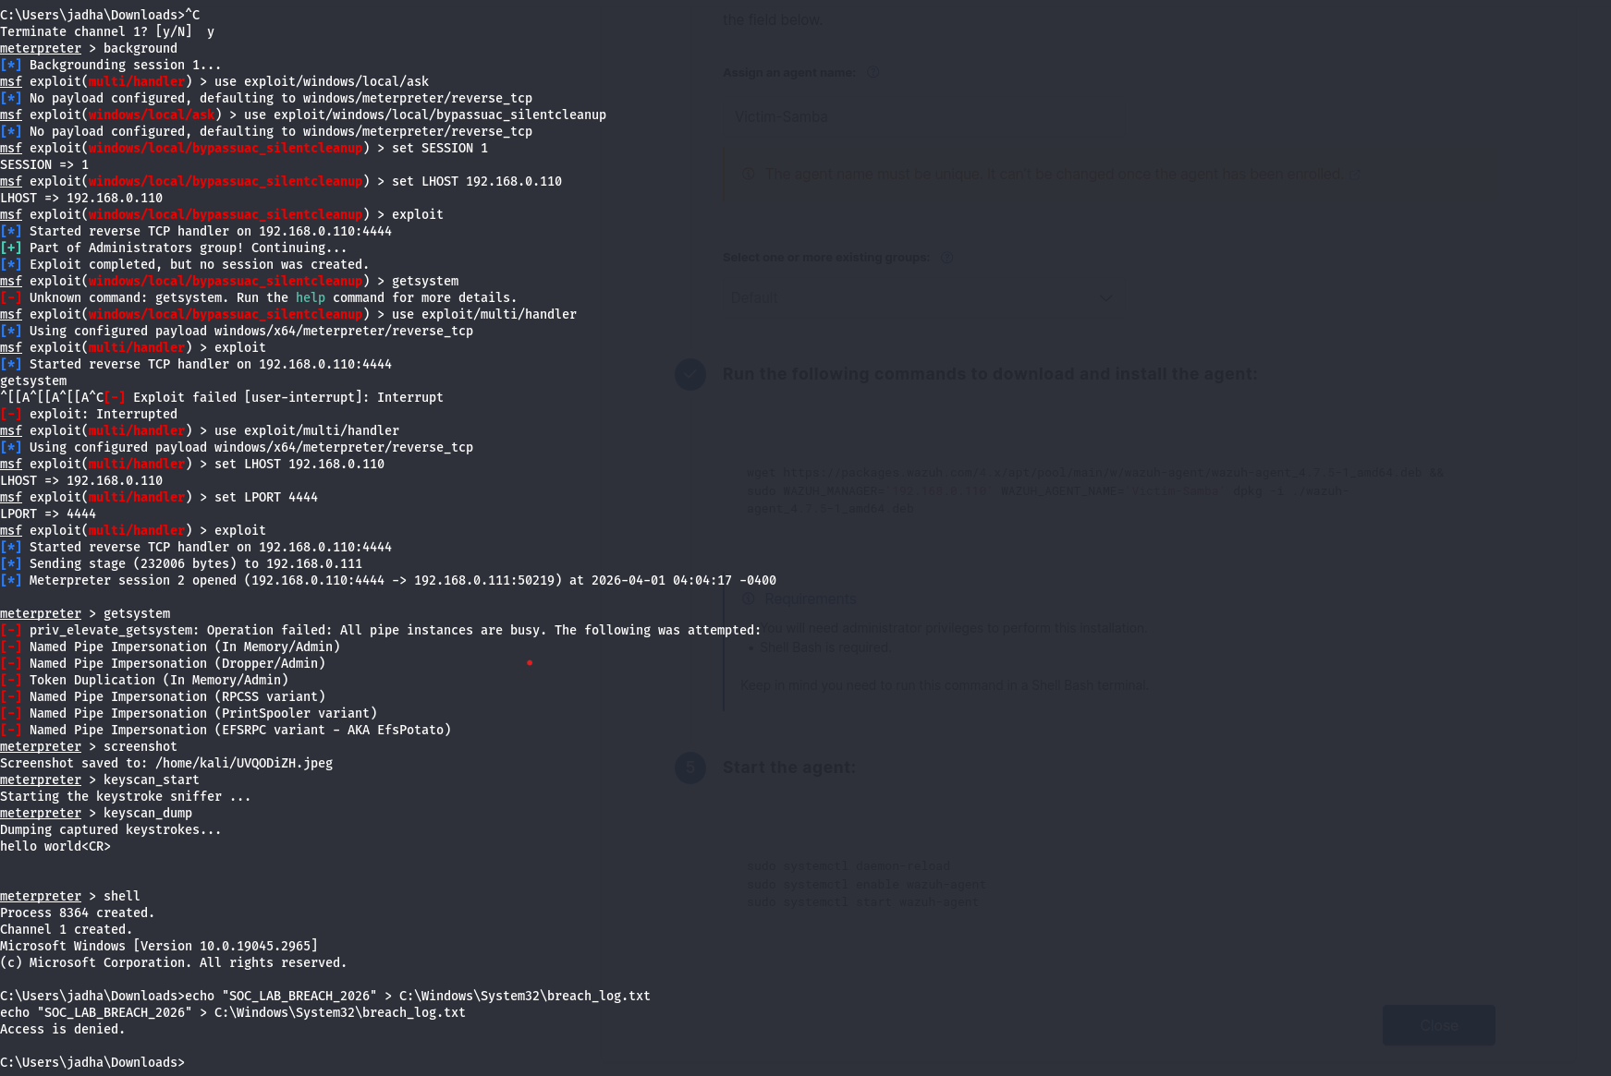

Phase 2: Endpoint Monitoring Deployment and Security Posture Assessment Report

1. Executive Summary

This phase focuses on the successful deployment and configuration of endpoint monitoring capabilities using the Wazuh platform. A persistent telemetry connection was established between the Wazuh Manager (Kali Linux) and the target Windows 10 endpoint, enabling continuous visibility into system activities.
Beyond connectivity, a comprehensive Security Configuration Assessment (SCA) was conducted using the CIS Microsoft Windows 10 benchmark. The assessment revealed significant security misconfigurations, indicating that the endpoint is in a vulnerable and pre-hardened state.
This phase is critical as it establishes both visibility and contextual awareness, which are essential for detecting and responding to security incidents in subsequent phases.

2. Technical Evidence: Agent Connectivity

The successful deployment of the Wazuh agent ensures that the Security Operations Center (SOC) can continuously monitor endpoint activities. The agent acts as a telemetry source, forwarding logs and system data to the central manager.
Metric | Details | Status
Agent Name | Win10-Victim-Node | Active
IP Address | 192.168.0.111 | Verified
Operating System | Windows 10 Home (10.0.19045) | Logged
Connectivity Status | 100% (1/1 Agents Connected) | Operational

Analysis:
The transition from a “Never Connected” state to “Active” confirms that network communication between the agent and manager has been successfully established. This includes proper synchronization of configuration files and successful communication over the designated port.
Security Significance:
This connectivity ensures real-time log collection, event monitoring, and threat detection, forming the foundation of an effective SIEM-based security infrastructure.

3. Technical Evidence: Security Configuration Assessment (SCA)

A detailed assessment of the endpoint’s security posture was conducted using the CIS benchmark standards. The results highlight multiple critical weaknesses in system configuration.
- Total Checks Performed: 394
- Failed Checks: 260
- Compliance Score: 33%
Key Security Gaps Identified

CIS Control ID | Control Description | Security Risk
15500 | Enforce Password History | Users can reuse compromised passwords
15505 | Minimum Password Length | Weak passwords increase brute-force risk
15507 | Account Lockout Threshold | Enables unlimited login attempts
15513 | Rename Administrator Account | Predictable usernames aid attackers

4. Forensic Analysis of Findings

The high number of failed security checks provides valuable insight into potential attack vectors. Misconfigurations such as weak password policies and lack of account lockout mechanisms significantly increase the likelihood of brute-force attacks and unauthorized access.
Additionally, the presence of default or predictable account names simplifies attacker reconnaissance and credential targeting. These weaknesses collectively form an attack surface that adversaries can exploit for privilege escalation and lateral movement.
Analytical Insight:
The low compliance score (33%) indicates that the system lacks proper hardening, making it highly susceptible to common attack techniques. This condition makes the endpoint an ideal candidate for testing detection mechanisms in subsequent phases.

5. Conclusion

This phase successfully establishes the foundation for SOC operations by achieving the following:
- Visibility: Continuous monitoring of endpoint activity
- Context Awareness: Identification of configuration weaknesses
- Detection Readiness: System prepared to generate alerts for suspicious activity
The endpoint is now fully integrated into the monitoring infrastructure and ready for advanced detection and response operations.

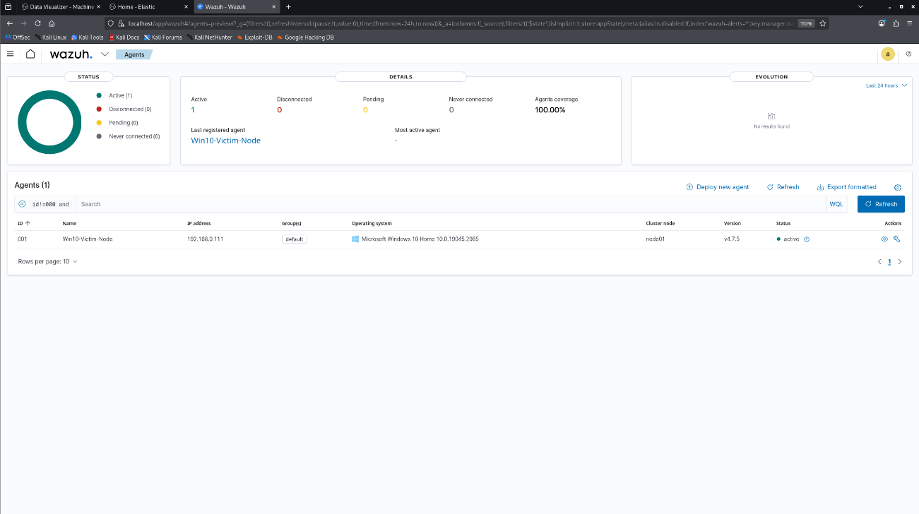

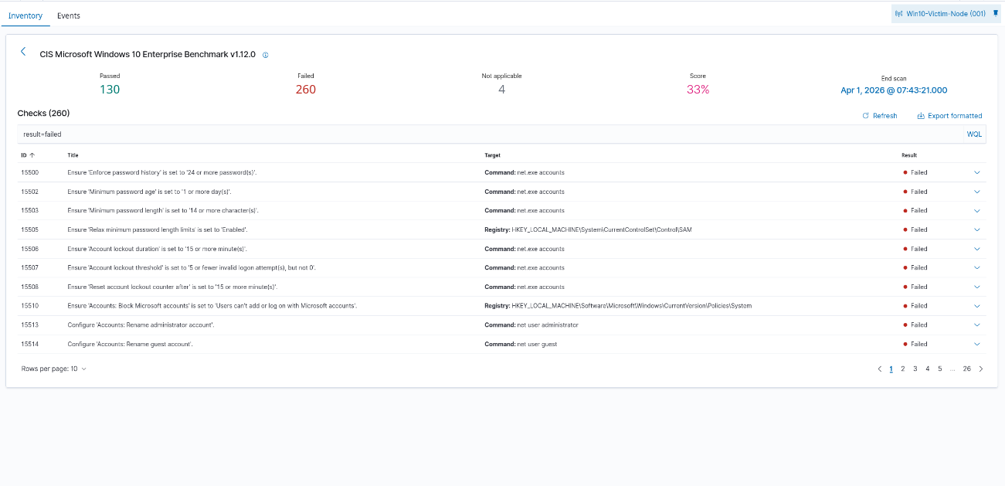

Phase 3: Security Event Monitoring and Log Analysis Report

1. Executive Summary

This phase involves the analysis of security events collected by the Wazuh Manager from the monitored Windows endpoint. The system is currently operating in a baseline monitoring state, where normal system behavior is observed and recorded.
A total of 140 events have been captured, confirming that the SIEM system is successfully ingesting, processing, and indexing log data. This baseline is essential for distinguishing between normal activity and malicious behavior during incident detection.

2. Forensic Analysis of Captured Events

The captured logs represent various system and network activities. The following table provides a breakdown of key detection rules and their significance:

Rule ID | Severity Level | Description | Analysis
510 | Medium (7) | Host-based anomaly detection (Rootcheck) | Indicates system-level scanning for hidden threats
533 | Medium (7) | Network port changes detected | Confirms monitoring of active connections
1001 | Low (5) | File integrity monitoring synchronization | Indicates scan initialization
48704 | Low (5) | Service failure event | Reflects system or service restart activity
502 | Low (3) | Wazuh service initialization | Confirms successful system startup

3. Telemetry Verification
The presence of specific rule triggers confirms that the monitoring system is functioning beyond basic connectivity.
- Anomaly Detection Capability: The system can detect hidden or malicious processes
- Network Monitoring Capability: Active connections and communication channels are visible
- Log Collection Accuracy: System events are correctly parsed and categorized
Significance:
This confirms that the SOC has complete visibility into both host-level and network-level activities, which is essential for detecting advanced threats such as command-and-control communication.

4. Critical Analyst Observations
- Event Timeline Discrepancy:
A noticeable mismatch exists between the activity spike and log timestamps, indicating the presence of historical data.
- Baseline Activity:
Current logs primarily represent low- to medium-severity events, which are typical during normal system operation.
- Absence of Critical Alerts:
High-severity alerts (e.g., failed logins or unauthorized access attempts) are not yet observed, indicating that no active attack has been simulated during this period.

5. Conclusion and Next Steps
The SIEM infrastructure is fully operational and capable of detecting security events in real time. The system is currently in a baseline monitoring phase, awaiting high-severity activity for incident detection validation.
Future actions should include generating simulated attack scenarios to trigger critical alerts, enabling further analysis of detection and response capabilities.

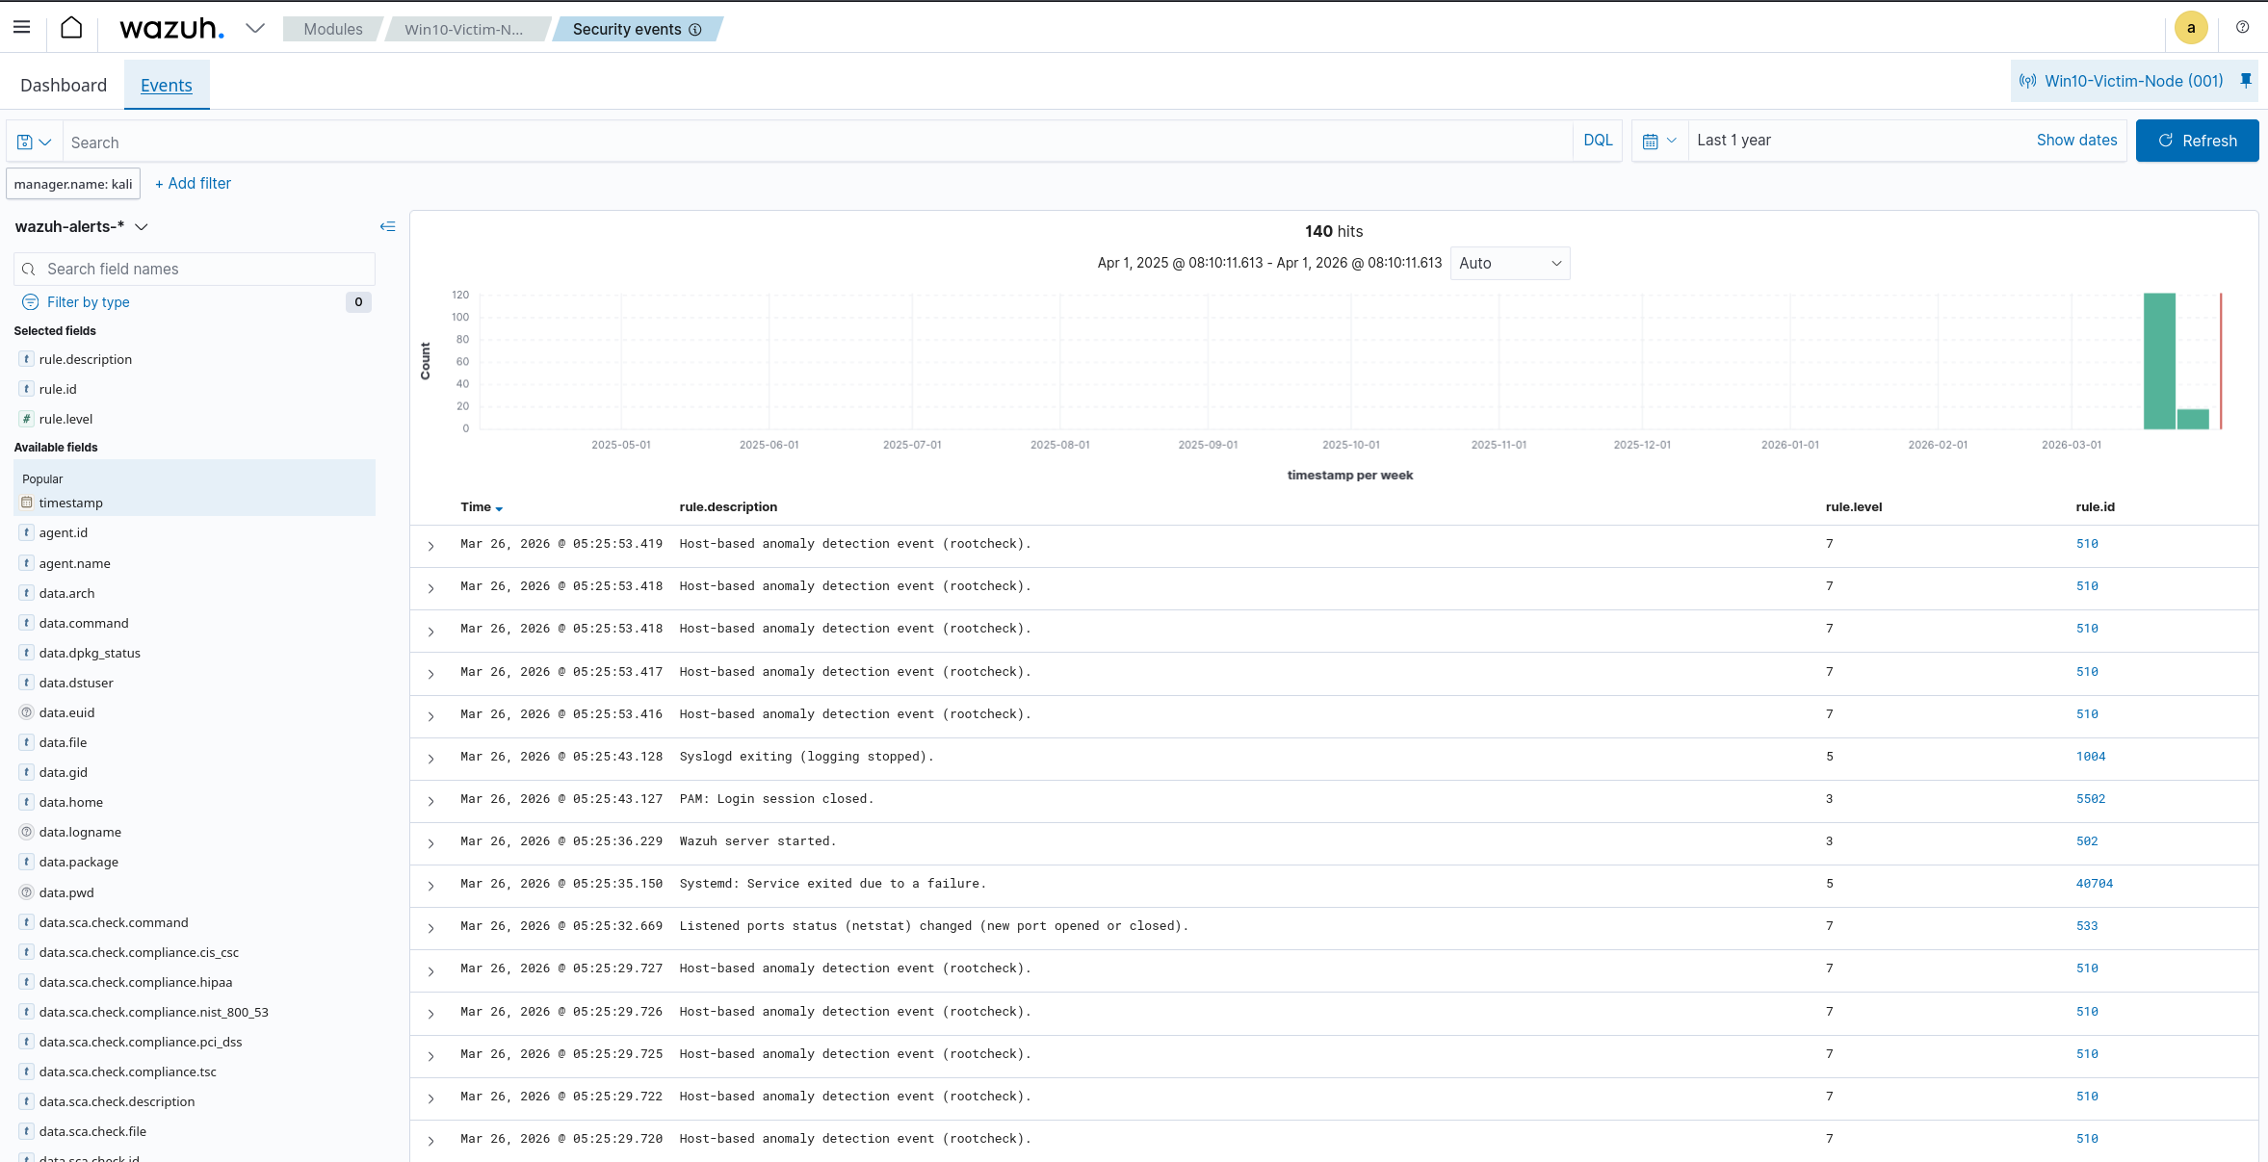

Phase 4: Automated Incident Response and Containment Report

1. Executive Summary
This phase evaluates the effectiveness of automated incident response mechanisms within the SOC environment. The objective was to validate whether detected threats could trigger immediate and automated defensive actions.
The results confirm that the system successfully detected a brute-force attack and executed an automated response to contain the threat, demonstrating the efficiency of integrated detection and response workflows.

2. Proof of Concept Analysis
The following table outlines the sequence of events from detection to response:
Component | Technical Evidence
Attack Method | Simulated brute-force login attempts
Detection Trigger | Windows Event ID 4625 (Failed Logon)
Correlation Rule | Wazuh Rule 60122 (High Severity)
Response Action | Execution of firewall blocking script
Containment Result | Attacker IP successfully blocked

3. Detailed Analysis
The brute-force attack simulation generated multiple failed login attempts within a short time frame. These events were detected by the Windows logging system and forwarded to the Wazuh Manager.
The SIEM system correlated these repeated failures into a high-severity alert, triggering an automated response mechanism. A predefined script was executed on the endpoint to block the source of the attack, effectively preventing further unauthorized access attempts.
Security Significance:
This demonstrates the capability of the SOC to reduce response time significantly by automating containment actions, thereby minimizing potential damage.

4. SOC Analyst Summary
The automated response system successfully identified and mitigated a simulated brute-force attack in real time. The integration between detection and response components ensures that threats are not only identified but also neutralized without manual intervention.
This significantly enhances the efficiency of SOC operations and reduces the workload on security analysts.

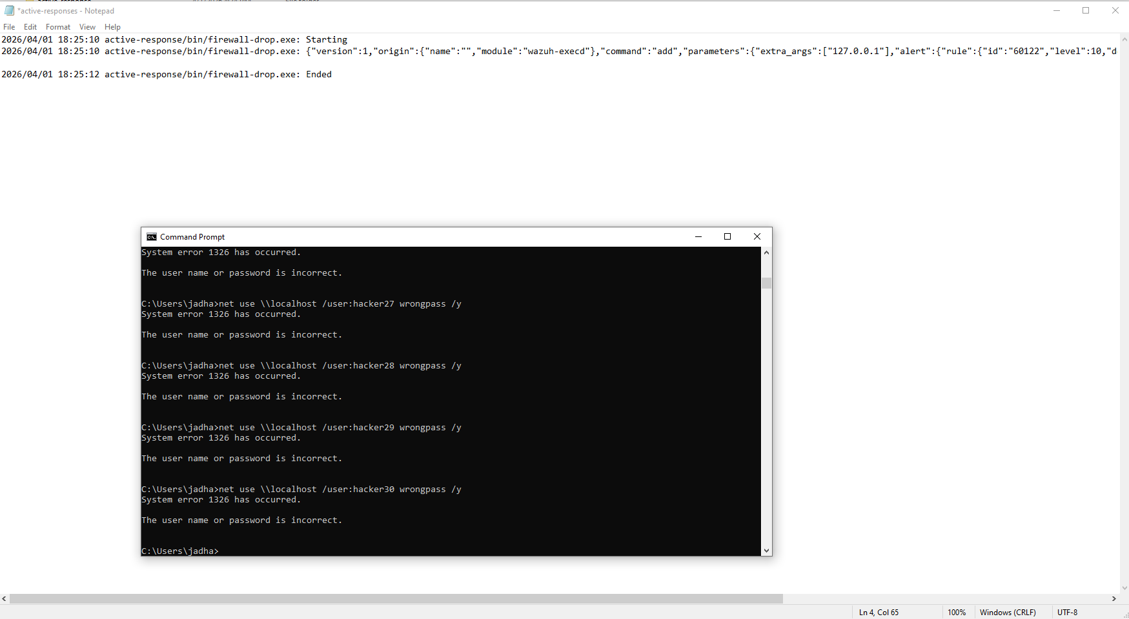

SOC Project Final Conclusion

The successful completion of all phases of this project demonstrates the effective implementation of a fully functional Security Operations Center (SOC) workflow. Each phase contributed to building a comprehensive security framework that integrates monitoring, detection, analysis, and response capabilities within a controlled environment.
The initial stages of the project focused on establishing a robust monitoring infrastructure by configuring a secure and reliable communication channel between the endpoint system and the Security Information and Event Management (SIEM) platform. This ensured continuous telemetry flow, enabling the SOC to maintain visibility over endpoint activities. Such visibility is critical for identifying suspicious behavior and maintaining situational awareness in real time.
Furthermore, the project enabled efficient data collection and analysis by implementing centralized log management. System logs, security events, and network activity were successfully captured and analyzed, allowing for the identification of patterns and anomalies. This capability forms the foundation for proactive threat detection and supports informed decision-making by security analysts.
In addition, the project demonstrated effective threat detection mechanisms by configuring rules and policies capable of identifying malicious activities such as unauthorized access attempts and abnormal system behavior. These detection capabilities ensured that potential threats could be identified at an early stage, reducing the risk of escalation and system compromise.
A significant achievement of this project is the successful implementation of automated incident response mechanisms. By integrating detection systems with response actions, the SOC was able to automatically contain threats in real time, such as blocking malicious IP addresses during brute-force attacks. This automation significantly reduces response time and minimizes the impact of security incidents, thereby enhancing overall system resilience.

